LAB EXPERIMENT 9

AIM
To design and develop an Online Electronic Gadget Shopping System using HTML, CSS, and JavaScript that allows users to browse products, search and filter gadgets, check availability, add or remove items from the shopping cart, place orders, track order status, and view order history. The system also enables administrators to add, remove, and update product details, prices, and descriptions.

PROCEDURE
- Create a project folder named TechSavvy and create an HTML file named index.html.
- Design the home page using HTML to display electronic gadgets and product categories.
- Use CSS to style the website and make it user-friendly and responsive.
- Use JavaScript to display products such as smartphones, laptops, tablets, and accessories.
- Implement product search, category filtering, and product availability checking.
- Create shopping cart functionality to add, edit, and remove products.
- Develop the checkout section to collect customer details and place orders.
- Implement order status checking and order history features.
- Create an admin section to add, remove, and update product details, prices, and descriptions.
- Run the website in a browser and test all the functionalities.

CODE
<!DOCTYPE html>
<html>
<head>
<title>TechSavvy Shopping</title>
<style>
body{font-family:Arial;margin:20px;background:#f2f2f2}
h1{text-align:center;background:#222;color:white;padding:15px}
input,select,button{padding:8px;margin:5px}
.products{display:flex;flex-wrap:wrap;gap:15px}
.card{background:white;padding:15px;width:200px;border-radius:8px}
button{background:#007bff;color:white;border:0;cursor:pointer}
#cart{background:white;padding:15px;margin-top:20px}
</style>
</head>
<body>
<h1>TechSavvy - Online Gadget Store</h1>
<input id="search" placeholder="Search gadgets" oninput="showProducts()">
<select id="category" onchange="showProducts()">
<option value="All">All Categories</option>
<option>Smartphones</option>
<option>Laptops</option>
<option>Tablets</option>
<option>Accessories</option>
</select>
<div id="products" class="products"></div>
<div id="cart"><h2>Shopping Cart</h2><div id="items"></div>
<p id="total">Total: ₹0</p>
<button onclick="checkout()">Checkout</button>
</div>
<h2>Check Order Status</h2>
<input id="orderId" placeholder="Enter Order ID">
<button onclick="checkStatus()">Check Status</button>
<p id="status"></p>
<h2>Admin - Add Product</h2>
<input id="pname" placeholder="Product Name">
<input id="price" type="number" placeholder="Price">
<select id="pcat">
<option>Smartphones</option><option>Laptops</option>
<option>Tablets</option><option>Accessories</option>
</select>
<button onclick="addProduct()">Add Product</button>
<script>
let products=[
{name:"Smartphone",price:15000,cat:"Smartphones",stock:5},
{name:"Laptop",price:45000,cat:"Laptops",stock:3},
{name:"Tablet",price:20000,cat:"Tablets",stock:4},
{name:"Headphones",price:1500,cat:"Accessories",stock:10}
];
let cart=[],orders=[];
function showProducts(){
let s=document.getElementById("search").value.toLowerCase();
let c=document.getElementById("category").value;
document.getElementById("products").innerHTML="";
products.filter(p=>p.name.toLowerCase().includes(s)&&(c==="All"||p.cat===c)).forEach((p,i)=>{
document.getElementById("products").innerHTML+=
`<div class="card"><h3>${p.name}</h3><p>Category: ${p.cat}</p><p>Price: ₹${p.price}</p><p>Available: ${p.stock}</p><button onclick="addCart(${products.indexOf(p)})">Add to Cart</button><button onclick="removeProduct(${products.indexOf(p)})">Remove</button></div>`;
});
}
function addCart(i){
if(products[i].stock<=0)return alert("Out of stock");
let item=cart.find(x=>x.i===i);
if(item)item.qty++;else cart.push({i,qty:1});
products[i].stock--;showProducts();showCart();
}
function showCart(){
let total=0;
document.getElementById("items").innerHTML=cart.map((x,j)=>{
let p=products[x.i];total+=p.price*x.qty;
return `${p.name} - ₹${p.price} x ${x.qty}
<button onclick="changeQty(${j},1)">+</button>
<button onclick="changeQty(${j},-1)">-</button>
<button onclick="removeCart(${j})">Remove</button>`;
}).join("<br>");
document.getElementById("total").innerText="Total: ₹"+total;
}
function changeQty(j,n){
let x=cart[j];
if(n>0&&products[x.i].stock>0){x.qty++;products[x.i].stock--;}
else if(n<0){x.qty--;products[x.i].stock++;if(x.qty===0)cart.splice(j,1);}
showProducts();showCart();
}
function removeCart(j){
let x=cart[j];products[x.i].stock+=x.qty;
cart.splice(j,1);showProducts();showCart();
}
function removeProduct(i){
if(cart.some(x=>x.i===i))return alert("Remove product from cart first");
products.splice(i,1);showProducts();
}
function checkout(){
if(!cart.length)return alert("Cart is empty");
let id="TS"+Math.floor(Math.random()*9000+1000);
orders.push({id,status:"Order Placed"});
alert("Order placed! Order ID: "+id);
cart=[];showCart();showProducts();
}
function checkStatus(){
let o=orders.find(x=>x.id===document.getElementById("orderId").value);
document.getElementById("status").innerText=o?o.status:"Order not found";
}
function addProduct(){
let name=document.getElementById("pname").value;
let price=Number(document.getElementById("price").value);
let cat=document.getElementById("pcat").value;
if(!name||price<=0)return alert("Enter valid product details");
products.push({name,price,cat,stock:5});
showProducts();alert("Product added");
}
showProducts();
</script>
</body>
</html>

IMPLEMENTATION
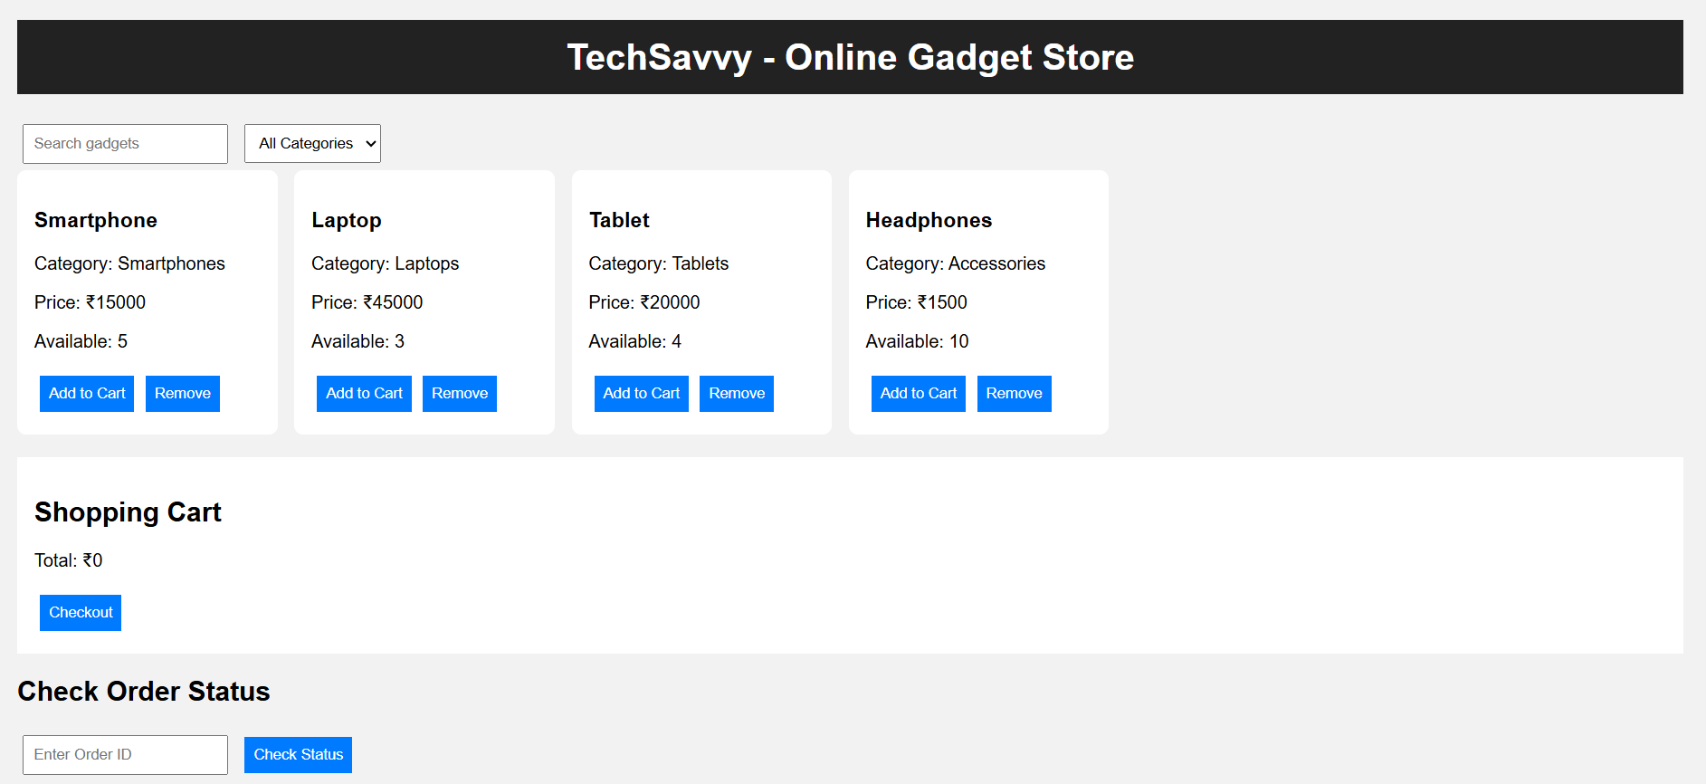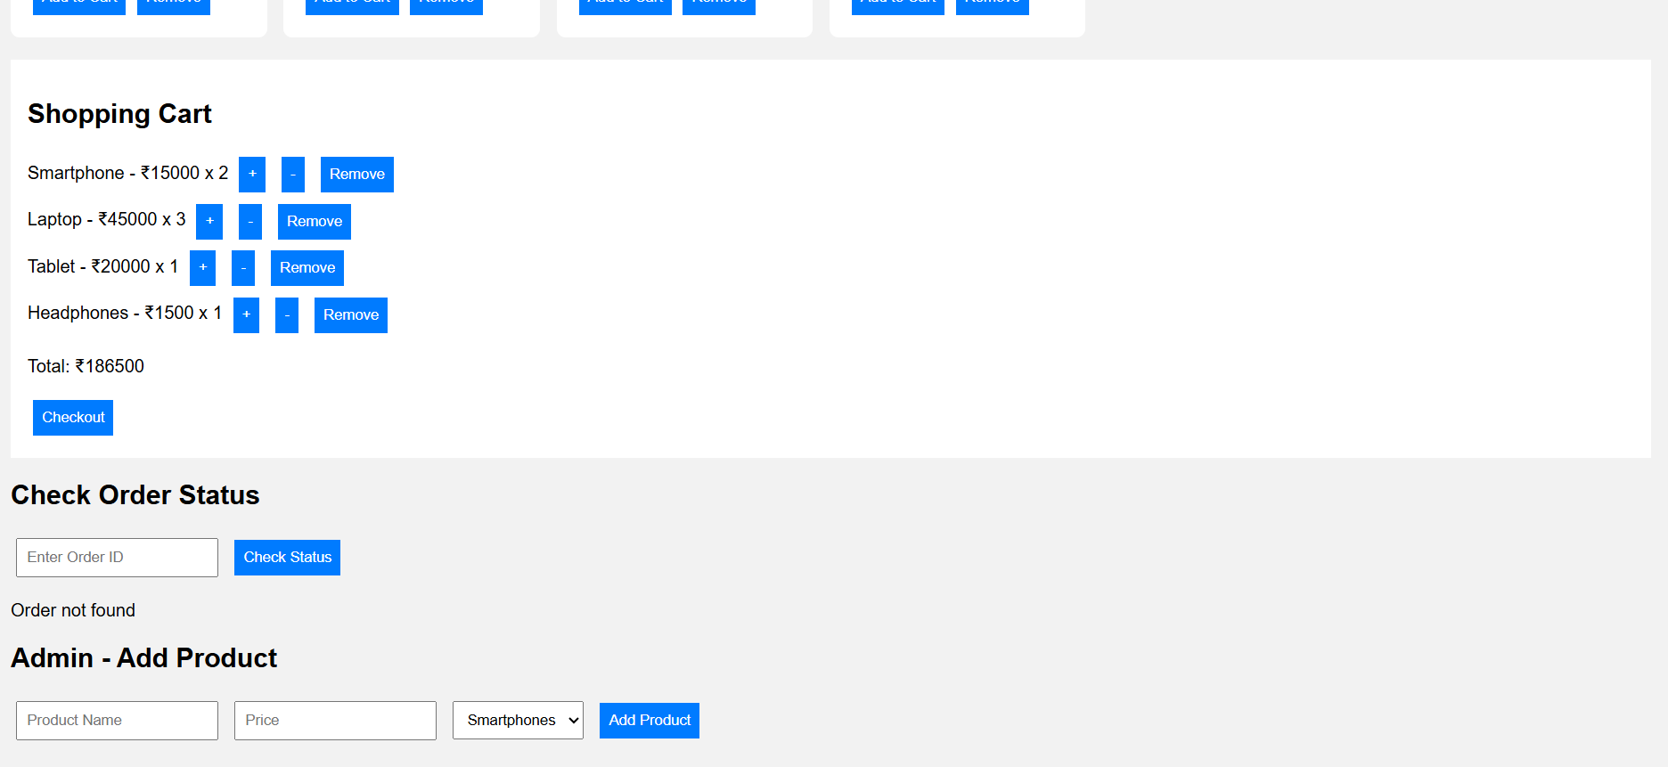

RESULT
Thus, the Online Electronic Gadget Shopping System (TechSavvy) was successfully designed and implemented using HTML, CSS, and JavaScript. The system allows users to browse electronic gadgets, search and filter products, check availability, add or remove items from the shopping cart, place orders, and check order status. It also enables the administrator to add and remove products and manage product prices through a simple and user-friendly interface.

